DefinitelyNotNitro.zip
Forensics | Medium
Description | My friend sent me a torrent link to get Discord Nitro for free??? I've been on Skype for so long that this might finally be my chance to leave it for good! I started the download but I think my VPN failed along the way. Help me recover the download and get me my free Nitro.
Files | Single Docker container, built from challenge/. From this directory:  docker build -t rowdy06-nitro:local challenge  docker run -d --name rowdy06-nitro -p 18106:18106 \  --read-only --cap-drop=ALL \  --security-opt=no-new-privileges rowdy06-nitro:local  Open http://localhost:18106. Players download DefinitelyNotNitro.torrent and transfer-session.pcap from the toolbar. The other downloads are optional music, wallpapers, sounds, and video. All files are included; play needs no accounts or outside connections. Reset session restores the client. Stop the container with docker stop rowdy06-nitro.  Keep this document, organizer/, and screenshots/ private. Maintenance commands are in organizer/OPERATIONS.md.
Hint(s) | 1. The peer list is more useful than the order packets arrived.  2. Piece messages describe where their data belongs; the torrent file describes what valid pieces look like.  3. Reassemble TCP, place piece data by index and offset, and use the metadata's hashes to choose valid retransmissions.
Walkthrough | Use Wireshark (including TShark) and Python 3.  1. Save the evidence. Download the capture and torrent into one folder using the toolbar below. The saved log records a completed transfer followed by a disk-write error, so recover the ZIP from the captured traffic.  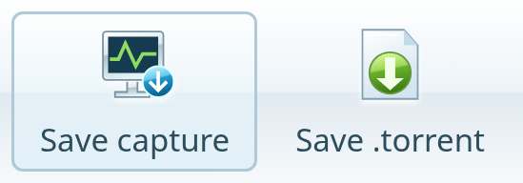  2. Reassemble the traffic. Open transfer-session.pcap in Wireshark. Under Preferences → Protocols, enable the TCP and BitTorrent options shown below so messages spanning several packets are decoded together.  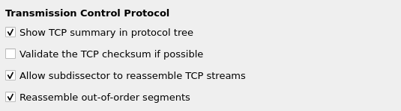  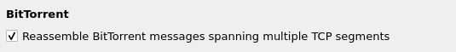  3. Inspect a piece. Filter on bittorrent.msg.type == 7 and expand a Piece message. Its index identifies the piece, its offset locates the block within it, and its data supplies the file bytes.  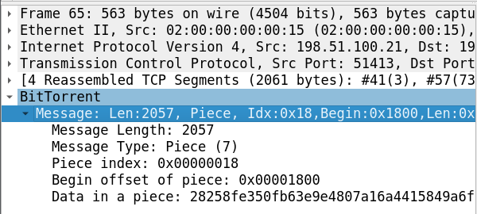  4. Rebuild the ZIP. Save this as recover.py beside the downloads. TShark reassembles the connections; the script places their blocks and uses the torrent's hashes to select intact copies.  from collections import defaultdict  from hashlib import sha1  from pathlib import Path  import bencodepy, shutil, subprocess  info = bencodepy.decode(  Path("DefinitelyNotNitro.torrent").read_bytes())[b"info"]  size, total = info[b"piece length"], info[b"length"]  hashes = info[b"pieces"]  tshark = shutil.which("tshark") or (  r"C:\Program Files\Wireshark\tshark.exe")  command = [tshark, "-r", "transfer-session.pcap",  "-o", "tcp.reassemble_out_of_order:TRUE",  "-o", "bittorrent.desegment:TRUE",  "-Y", "bittorrent.msg.type == 7", "-T", "fields"]  for field in ["tcp.stream", "bittorrent.piece.index",  "bittorrent.piece.begin", "bittorrent.piece.data"]:  command += ["-e", field]  rows = subprocess.check_output(  command, text=True, stderr=subprocess.DEVNULL)  # Keep each connection's copies separate.  blocks = defaultdict(dict)  for row in rows.splitlines():  peer, indices, offsets, data = row.split("\t")  for i, offset, raw in zip(indices.split(","),  offsets.split(","), data.split(",")):  blocks[peer, int(i, 0)][int(offset, 0)] = bytes.fromhex(raw)  # Place blocks by offset and keep intact pieces.  pieces = {}  for (_, i), parts in blocks.items():  piece = bytearray(min(size, total - i * size))  for offset, data in parts.items():  piece[offset:offset + len(data)] = data  if sha1(piece).digest() == hashes[i * 20:(i + 1) * 20]:  pieces[i] = piece  archive = b"".join(pieces[i] for i in range(len(hashes) // 20))  Path("DefinitelyNotNitro.zip").write_bytes(archive)  print("Recovered DefinitelyNotNitro.zip")  Run from that folder in PowerShell:  py -m pip install bencodepy==0.9.5  py recover.py  5. Read the redemption card. Extract DefinitelyNotNitro.zip and open OPEN_ME.png. The Discord Nitrogen redemption code is the flag.  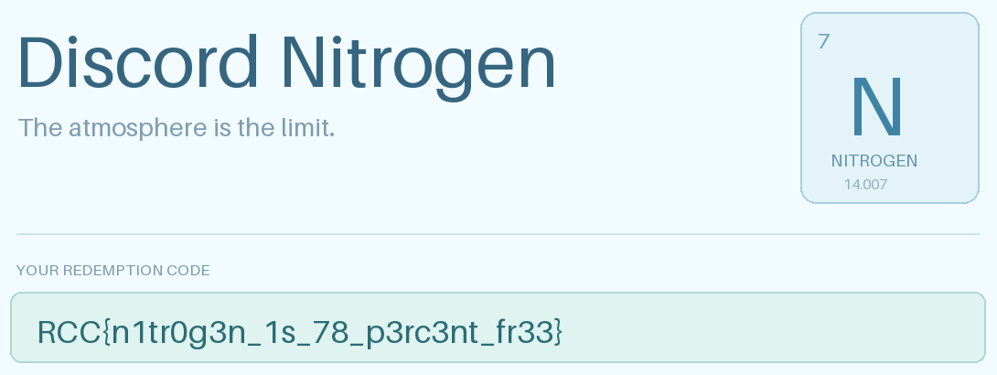
Flag | RCC{n1tr0g3n_1s_78_p3rc3nt_fr33}

